KD1E

Portable AC/DC neon indicator with domed contact electrode for use on systems up to 11kV
- AC/DC neon indicators
- UK Electricity Council Approval list G9

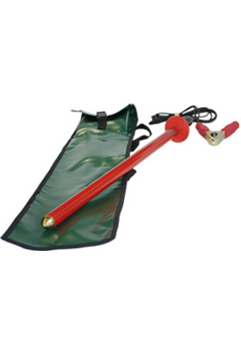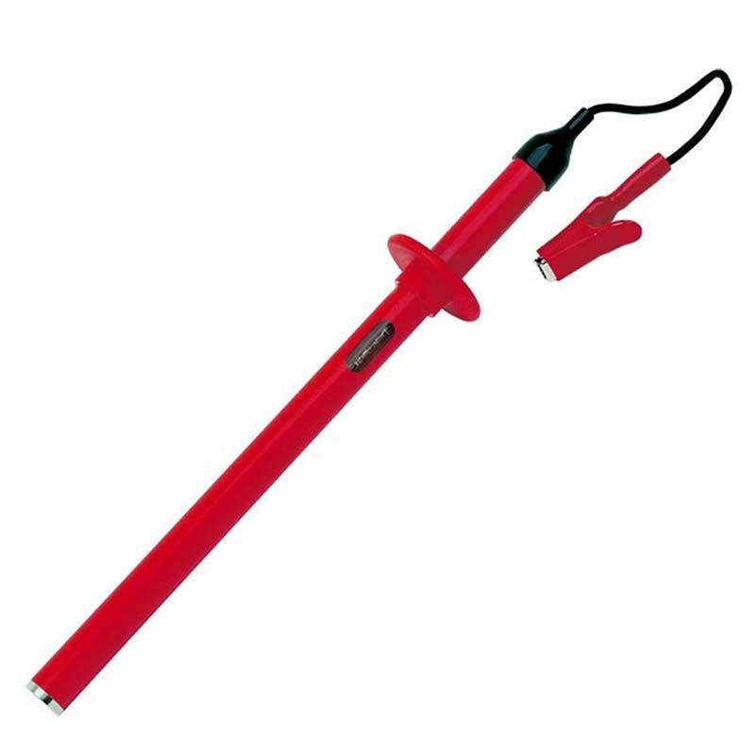

KD1E
The KD1E is a neon HV potential indicator suitable for use on earthed neutral systems up to 11kV. A highly robust, portable AC/DC voltage indicator, this potential indicator provides a means of confirming the presence of voltage on earthed neutral electrical circuits.
Conforming in design lengths to recommended creepage and safety standards, the KDIE series features high grade PVC tubing and incorporates totally encapsulated resistor chains. For additional safety a proving unit (PH3) is available and should be used before and after the high voltage indicator is employed.

Technical specification
Maximum system voltage | 11kV
Maximum voltage to earth | 6.6kV
Threshold voltage | 300V
Measuring range | N/A
Resolution | N/A
Sensitivity | AC/DC
Circuit current (IEC 61234-2) | 2.3mA nominal @6.6kV
Dielectric leakage current (IEC 61234-2) | 7uA nominal @ 13.8kV
Length (mm) | 330
Diameter (mm) | 25
Handle length (mm) | 105
Hand guard height (mm) | 23.5
Contact electrode type | Domed

